**SDF PROJECT REPORT**

**LOGIN AND REGISTRATION SYSTEM**

**Subject- SDF-2 LAB**

**Subject Code- 15B17CI271**

**Members-**

**Name Roll Number Batch**

**Aryesh Srivastava 21803026 (B12B)**

**Overview:-**

We have chosen to make a login and registration system for our software project. The project is built in C++ programming language, it uses UI Forms and Microsoft SQL Server to let the users login and register into the system, where each user has their unique username. The Forms have a Graphical User Interface for ease of use for everybody.

**Design of the project:-**

* On running the project code the user is displayed with a GUI Login form with three labels ‘Login’, ‘Email’ and ‘Password’. ‘Email’ and ‘Password’ have text boxes. There are two buttons ‘Login’ and ‘Cancel’. Also there is a link label ‘Register’ that takes us to the Register Form.
* The ‘Login’ button checks whether all fields are filled and gives an error message, asking for the user to enter all fields. After pressing the button, the Microsoft SQL Server is checked for the details. If the data is found, we are taken to the ‘Welcome to the Dashboard’ page which prints all the user data. If the data is not found then we are taken to the Registration Form. The ‘cancel’ button terminates the program.
* The Registration Form has a label called ‘Register’ and six more labels with text boxes, which includes ‘Name’, ‘Email’, ‘Phone’, ‘Address’, ‘Password’ and ‘Confirm Password’. This Form also has two buttons which are ‘Register’ and ‘Cancel’. It also has a link label called ‘Login’ which takes us to the Login Form.
* On pressing the ‘Register’ button, the program checks whether all fields are properly filled and if not, it displays an error message asking the user to enter all fields. We have also used Exception Handling to see whether the strings entered in ‘Password’ and ‘Confirm Password’ are equal or not, upon which the program displays an appropriate error message. After checking these conditions, the user data is stored in the Microsoft SQL Server for further use and we are redirected to the Login Form. The ‘cancel button ends the program. Now that the user is successfully registered they can login if they enter the correct email and password.

**Concepts used in the project:-**

* Data types, variables, constants, keywords in C++ programming.
* Operators: binary, unary, operator precedence, operations using different operators in C++
* Classes and Objects in C++
* Conditional statements in C++
* Loops in C++ like for, while, do-while
* Array, Multidimensional Array
* Strings, string library functions and its programs
* Functions in C++
* Microsoft SQL Server
* Exception Handling in C++
* GUI Forms which uses concepts like-

1. Labels
2. Link Labels
3. Text Boxes
4. Buttons

**Code** **Implementation**:-

**Login Form**

#pragma once

#include "User.h"

namespace SDFProject {

using namespace System;

using namespace System::ComponentModel;

using namespace System::Collections;

using namespace System::Windows::Forms;

using namespace System::Data;

using namespace System::Drawing;

using namespace System::Data::SqlClient;

/// <summary>

/// Summary for LoginForm

/// </summary>

public ref class LoginForm : public System::Windows::Forms::Form

{

public:

LoginForm(void)

{

InitializeComponent();

//

//TODO: Add the constructor code here

//

}

protected:

/// <summary>

/// Clean up any resources being used.

/// </summary>

~LoginForm()

{

if (components)

{

delete components;

}

}

private: System::Windows::Forms::Label^ label1;

protected:

private: System::Windows::Forms::Label^ label2;

private: System::Windows::Forms::Label^ label3;

private: System::Windows::Forms::TextBox^ tbEmail;

private: System::Windows::Forms::TextBox^ tbPassword;

private: System::Windows::Forms::Button^ btnOK;

private: System::Windows::Forms::Button^ btnCancel;

private: System::Windows::Forms::LinkLabel^ linkLabel1;

private:

/// <summary>

/// Required designer variable.

/// </summary>

System::ComponentModel::Container ^components;

#pragma region Windows Form Designer generated code

/// <summary>

/// Required method for Designer support - do not modify

/// the contents of this method with the code editor.

/// </summary>

void InitializeComponent(void)

{

this->label1 = (gcnew System::Windows::Forms::Label());

this->label2 = (gcnew System::Windows::Forms::Label());

this->label3 = (gcnew System::Windows::Forms::Label());

this->tbEmail = (gcnew System::Windows::Forms::TextBox());

this->tbPassword = (gcnew System::Windows::Forms::TextBox());

this->btnOK = (gcnew System::Windows::Forms::Button());

this->btnCancel = (gcnew System::Windows::Forms::Button());

this->linkLabel1 = (gcnew System::Windows::Forms::LinkLabel());

this->SuspendLayout();

//

// label1

//

this->label1->Anchor = static_cast<System::Windows::Forms::AnchorStyles>(((System::Windows::Forms::AnchorStyles::Top | System::Windows::Forms::AnchorStyles::Left)

| System::Windows::Forms::AnchorStyles::Right));

this->label1->Font = (gcnew System::Drawing::Font(L"Microsoft Sans Serif", 25.8F, System::Drawing::FontStyle::Regular, System::Drawing::GraphicsUnit::Point,

static_cast<System::Byte>(0)));

this->label1->Location = System::Drawing::Point(13, 13);

this->label1->Name = L"label1";

this->label1->Size = System::Drawing::Size(581, 62);

this->label1->TabIndex = 0;

this->label1->Text = L"Login";

this->label1->TextAlign = System::Drawing::ContentAlignment::MiddleCenter;

//

// label2

//

this->label2->Font = (gcnew System::Drawing::Font(L"Microsoft Sans Serif", 16.2F, System::Drawing::FontStyle::Regular, System::Drawing::GraphicsUnit::Point,

static_cast<System::Byte>(0)));

this->label2->Location = System::Drawing::Point(12, 94);

this->label2->Name = L"label2";

this->label2->Size = System::Drawing::Size(121, 45);

this->label2->TabIndex = 1;

this->label2->Text = L"Email";

this->label2->TextAlign = System::Drawing::ContentAlignment::MiddleCenter;

//

// label3

//

this->label3->Font = (gcnew System::Drawing::Font(L"Microsoft Sans Serif", 16.2F, System::Drawing::FontStyle::Regular, System::Drawing::GraphicsUnit::Point,

static_cast<System::Byte>(0)));

this->label3->Location = System::Drawing::Point(27, 163);

this->label3->Name = L"label3";

this->label3->Size = System::Drawing::Size(160, 39);

this->label3->TabIndex = 2;

this->label3->Text = L"Password";

//

// tbEmail

//

this->tbEmail->Font = (gcnew System::Drawing::Font(L"Microsoft Sans Serif", 12, System::Drawing::FontStyle::Regular, System::Drawing::GraphicsUnit::Point,

static_cast<System::Byte>(0)));

this->tbEmail->Location = System::Drawing::Point(193, 104);

this->tbEmail->Name = L"tbEmail";

this->tbEmail->Size = System::Drawing::Size(387, 30);

this->tbEmail->TabIndex = 3;

//

// tbPassword

//

this->tbPassword->Font = (gcnew System::Drawing::Font(L"Microsoft Sans Serif", 12, System::Drawing::FontStyle::Regular, System::Drawing::GraphicsUnit::Point,

static_cast<System::Byte>(0)));

this->tbPassword->Location = System::Drawing::Point(193, 163);

this->tbPassword->Name = L"tbPassword";

this->tbPassword->Size = System::Drawing::Size(387, 30);

this->tbPassword->TabIndex = 4;

//

// btnOK

//

this->btnOK->Font = (gcnew System::Drawing::Font(L"Microsoft Sans Serif", 18, System::Drawing::FontStyle::Regular, System::Drawing::GraphicsUnit::Point,

static_cast<System::Byte>(0)));

this->btnOK->Location = System::Drawing::Point(193, 258);

this->btnOK->Name = L"btnOK";

this->btnOK->Size = System::Drawing::Size(195, 55);

this->btnOK->TabIndex = 5;

this->btnOK->Text = L"Login";

this->btnOK->UseVisualStyleBackColor = true;

this->btnOK->Click += gcnew System::EventHandler(this, &LoginForm::btnOK_Click);

//

// btnCancel

//

this->btnCancel->Font = (gcnew System::Drawing::Font(L"Microsoft Sans Serif", 18, System::Drawing::FontStyle::Regular, System::Drawing::GraphicsUnit::Point,

static_cast<System::Byte>(0)));

this->btnCancel->Location = System::Drawing::Point(405, 258);

this->btnCancel->Name = L"btnCancel";

this->btnCancel->Size = System::Drawing::Size(175, 55);

this->btnCancel->TabIndex = 6;

this->btnCancel->Text = L"Cancel";

this->btnCancel->UseVisualStyleBackColor = true;

this->btnCancel->Click += gcnew System::EventHandler(this, &LoginForm::btnCancel_Click);

//

// linkLabel1

//

this->linkLabel1->Font = (gcnew System::Drawing::Font(L"Microsoft Sans Serif", 18, System::Drawing::FontStyle::Regular, System::Drawing::GraphicsUnit::Point,

static_cast<System::Byte>(0)));

this->linkLabel1->LinkColor = System::Drawing::Color::Black;

this->linkLabel1->Location = System::Drawing::Point(463, 339);

this->linkLabel1->Name = L"linkLabel1";

this->linkLabel1->Size = System::Drawing::Size(207, 52);

this->linkLabel1->TabIndex = 7;

this->linkLabel1->TabStop = true;

this->linkLabel1->Text = L"Register";

this->linkLabel1->LinkClicked += gcnew System::Windows::Forms::LinkLabelLinkClickedEventHandler(this, &LoginForm::linkLabel1_LinkClicked);

//

// LoginForm

//

this->AutoScaleDimensions = System::Drawing::SizeF(8, 16);

this->AutoScaleMode = System::Windows::Forms::AutoScaleMode::Font;

this->BackColor = System::Drawing::Color::Coral;

this->ClientSize = System::Drawing::Size(606, 416);

this->Controls->Add(this->linkLabel1);

this->Controls->Add(this->btnCancel);

this->Controls->Add(this->btnOK);

this->Controls->Add(this->tbPassword);

this->Controls->Add(this->tbEmail);

this->Controls->Add(this->label3);

this->Controls->Add(this->label2);

this->Controls->Add(this->label1);

this->Name = L"LoginForm";

this->Text = L"LoginForm";

this->Load += gcnew System::EventHandler(this, &LoginForm::LoginForm_Load);

this->ResumeLayout(false);

this->PerformLayout();

}

#pragma endregion

private: System::Void btnCancel_Click(System::Object^ sender, System::EventArgs^ e) {

this->Close();

}

public: User^ user = nullptr;

private: System::Void btnOK_Click(System::Object^ sender, System::EventArgs^ e) {

String^ email = this->tbEmail->Text;

String^ password = this->tbPassword->Text;

if (email->Length == 0 || password->Length == 0) {

MessageBox::Show("Please enter email and password",

"Email or Password Empty", MessageBoxButtons::OK);

return;

}

try {

String^ connString = "Data Source=DESKTOP-91QUR6S\\SQLEXPRESS;Initial Catalog=SDF;Integrated Security=True";

SqlConnection sqlConn(connString);

sqlConn.Open();

String^ sqlQuery = "SELECT * FROM users WHERE email=@email AND password=@pwd;";

SqlCommand command(sqlQuery, % sqlConn);

command.Parameters->AddWithValue("@email", email);

command.Parameters->AddWithValue("@pwd", password);

SqlDataReader^ reader = command.ExecuteReader();

if (reader->Read()) {

user = gcnew User;

user->id = reader->GetInt32(0);

user->name = reader->GetString(1);

user->email = reader->GetString(2);

user->phone = reader->GetString(3);

user->address = reader->GetString(4);

user->password = reader->GetString(5);

this->Close();

}

else {

MessageBox::Show("Email or password is incorrect",

"Email or Password Error", MessageBoxButtons::OK);

}

}

catch (Exception^ e) {

MessageBox::Show("Failed to connect to database",

"Database Connection Error", MessageBoxButtons::OK);

}

}

public: bool switchToRegister = false;

private: System::Void linkLabel1_LinkClicked(System::Object^ sender, System::Windows::Forms::LinkLabelLinkClickedEventArgs^ e) {

this->switchToRegister = true;

this->Close();

}

private: System::Void LoginForm_Load(System::Object^ sender, System::EventArgs^ e) {

}

};

}

**Main Form**

#pragma once

#include "User.h"

namespace SDFProject {

using namespace System;

using namespace System::ComponentModel;

using namespace System::Collections;

using namespace System::Windows::Forms;

using namespace System::Data;

using namespace System::Drawing;

/// <summary>

/// Summary for MainForm

/// </summary>

public ref class MainForm : public System::Windows::Forms::Form

{

public:

MainForm(User^ user)

{

InitializeComponent();

//

//TODO: Add the constructor code here

//

lbUserInfo->Text = "ID=" + user->id + ", Name=" + user->name +

", email=" + user->email + ", address=" + user->address;

}

protected:

/// <summary>

/// Clean up any resources being used.

/// </summary>

~MainForm()

{

if (components)

{

delete components;

}

}

private: System::Windows::Forms::Label^ label1;

private: System::Windows::Forms::Label^ lbUserInfo;

protected:

private:

/// <summary>

/// Required designer variable.

/// </summary>

System::ComponentModel::Container ^components;

#pragma region Windows Form Designer generated code

/// <summary>

/// Required method for Designer support - do not modify

/// the contents of this method with the code editor.

/// </summary>

void InitializeComponent(void)

{

this->label1 = (gcnew System::Windows::Forms::Label());

this->lbUserInfo = (gcnew System::Windows::Forms::Label());

this->SuspendLayout();

//

// label1

//

this->label1->Anchor = static_cast<System::Windows::Forms::AnchorStyles>(((System::Windows::Forms::AnchorStyles::Top | System::Windows::Forms::AnchorStyles::Left)

| System::Windows::Forms::AnchorStyles::Right));

this->label1->Font = (gcnew System::Drawing::Font(L"Microsoft Sans Serif", 30, System::Drawing::FontStyle::Regular, System::Drawing::GraphicsUnit::Point,

static_cast<System::Byte>(0)));

this->label1->Location = System::Drawing::Point(12, 9);

this->label1->Name = L"label1";

this->label1->Size = System::Drawing::Size(1010, 73);

this->label1->TabIndex = 0;

this->label1->Text = L"Welcome To Dashboard";

this->label1->TextAlign = System::Drawing::ContentAlignment::MiddleCenter;

//

// lbUserInfo

//

this->lbUserInfo->AutoSize = true;

this->lbUserInfo->Font = (gcnew System::Drawing::Font(L"Microsoft Sans Serif", 13.8F, System::Drawing::FontStyle::Regular, System::Drawing::GraphicsUnit::Point,

static_cast<System::Byte>(0)));

this->lbUserInfo->Location = System::Drawing::Point(12, 114);

this->lbUserInfo->Name = L"lbUserInfo";

this->lbUserInfo->Size = System::Drawing::Size(79, 29);

this->lbUserInfo->TabIndex = 1;

this->lbUserInfo->Text = L"label2";

//

// MainForm

//

this->AutoScaleDimensions = System::Drawing::SizeF(8, 16);

this->AutoScaleMode = System::Windows::Forms::AutoScaleMode::Font;

this->ClientSize = System::Drawing::Size(1034, 424);

this->Controls->Add(this->lbUserInfo);

this->Controls->Add(this->label1);

this->Name = L"MainForm";

this->Text = L"MainForm";

this->Load += gcnew System::EventHandler(this, &MainForm::MainForm_Load);

this->ResumeLayout(false);

this->PerformLayout();

}

#pragma endregion

private: System::Void MainForm_Load(System::Object^ sender, System::EventArgs^ e) {

}

};

}

**Registration Form**

#pragma once

#include "User.h"

namespace SDFProject {

using namespace System;

using namespace System::ComponentModel;

using namespace System::Collections;

using namespace System::Windows::Forms;

using namespace System::Data;

using namespace System::Drawing;

using namespace System::Data::SqlClient;

/// <summary>

/// Summary for RegisterForm

/// </summary>

public ref class RegisterForm : public System::Windows::Forms::Form

{

public:

RegisterForm(void)

{

InitializeComponent();

//

//TODO: Add the constructor code here

//

this->CenterToScreen();

}

protected:

/// <summary>

/// Clean up any resources being used.

/// </summary>

~RegisterForm()

{

if (components)

{

delete components;

}

}

private: System::Windows::Forms::Label^ label1;

protected:

private: System::Windows::Forms::Label^ label2;

private: System::Windows::Forms::TextBox^ tbName;

private: System::Windows::Forms::Label^ label3;

private: System::Windows::Forms::TextBox^ tbEmail;

private: System::Windows::Forms::Label^ label4;

private: System::Windows::Forms::TextBox^ tbPhone;

private: System::Windows::Forms::Label^ label5;

private: System::Windows::Forms::TextBox^ tbAddress;

private: System::Windows::Forms::Label^ label6;

private: System::Windows::Forms::TextBox^ tbPassword;

private: System::Windows::Forms::Label^ label7;

private: System::Windows::Forms::TextBox^ tbConfirmPassword;

private: System::Windows::Forms::Button^ btnOK;

private: System::Windows::Forms::Button^ btnCancel;

private: System::Windows::Forms::LinkLabel^ llLogin;

private:

/// <summary>

/// Required designer variable.

/// </summary>

System::ComponentModel::Container^ components;

#pragma region Windows Form Designer generated code

/// <summary>

/// Required method for Designer support - do not modify

/// the contents of this method with the code editor.

/// </summary>

void InitializeComponent(void)

{

this->label1 = (gcnew System::Windows::Forms::Label());

this->label2 = (gcnew System::Windows::Forms::Label());

this->tbName = (gcnew System::Windows::Forms::TextBox());

this->label3 = (gcnew System::Windows::Forms::Label());

this->tbEmail = (gcnew System::Windows::Forms::TextBox());

this->label4 = (gcnew System::Windows::Forms::Label());

this->tbPhone = (gcnew System::Windows::Forms::TextBox());

this->label5 = (gcnew System::Windows::Forms::Label());

this->tbAddress = (gcnew System::Windows::Forms::TextBox());

this->label6 = (gcnew System::Windows::Forms::Label());

this->tbPassword = (gcnew System::Windows::Forms::TextBox());

this->label7 = (gcnew System::Windows::Forms::Label());

this->tbConfirmPassword = (gcnew System::Windows::Forms::TextBox());

this->btnOK = (gcnew System::Windows::Forms::Button());

this->btnCancel = (gcnew System::Windows::Forms::Button());

this->llLogin = (gcnew System::Windows::Forms::LinkLabel());

this->SuspendLayout();

//

// label1

//

this->label1->Font = (gcnew System::Drawing::Font(L"Microsoft Sans Serif", 22.2F, System::Drawing::FontStyle::Regular, System::Drawing::GraphicsUnit::Point,

static_cast<System::Byte>(0)));

this->label1->Location = System::Drawing::Point(13, 13);

this->label1->Name = L"label1";

this->label1->Size = System::Drawing::Size(1003, 87);

this->label1->TabIndex = 0;

this->label1->Text = L"Register";

this->label1->TextAlign = System::Drawing::ContentAlignment::MiddleCenter;

//

// label2

//

this->label2->Font = (gcnew System::Drawing::Font(L"Microsoft Sans Serif", 22.2F, System::Drawing::FontStyle::Regular, System::Drawing::GraphicsUnit::Point,

static_cast<System::Byte>(0)));

this->label2->Location = System::Drawing::Point(53, 104);

this->label2->Name = L"label2";

this->label2->Size = System::Drawing::Size(159, 50);

this->label2->TabIndex = 1;

this->label2->Text = L"Name";

//

// tbName

//

this->tbName->Font = (gcnew System::Drawing::Font(L"Microsoft Sans Serif", 18, System::Drawing::FontStyle::Regular, System::Drawing::GraphicsUnit::Point,

static_cast<System::Byte>(0)));

this->tbName->Location = System::Drawing::Point(293, 107);

this->tbName->Name = L"tbName";

this->tbName->Size = System::Drawing::Size(640, 41);

this->tbName->TabIndex = 2;

//

// label3

//

this->label3->Font = (gcnew System::Drawing::Font(L"Microsoft Sans Serif", 22.2F, System::Drawing::FontStyle::Regular, System::Drawing::GraphicsUnit::Point,

static_cast<System::Byte>(0)));

this->label3->Location = System::Drawing::Point(53, 176);

this->label3->Name = L"label3";

this->label3->Size = System::Drawing::Size(159, 50);

this->label3->TabIndex = 1;

this->label3->Text = L"Email";

//

// tbEmail

//

this->tbEmail->Font = (gcnew System::Drawing::Font(L"Microsoft Sans Serif", 18, System::Drawing::FontStyle::Regular, System::Drawing::GraphicsUnit::Point,

static_cast<System::Byte>(0)));

this->tbEmail->Location = System::Drawing::Point(293, 179);

this->tbEmail->Name = L"tbEmail";

this->tbEmail->Size = System::Drawing::Size(640, 41);

this->tbEmail->TabIndex = 2;

//

// label4

//

this->label4->Font = (gcnew System::Drawing::Font(L"Microsoft Sans Serif", 22.2F, System::Drawing::FontStyle::Regular, System::Drawing::GraphicsUnit::Point,

static_cast<System::Byte>(0)));

this->label4->Location = System::Drawing::Point(53, 246);

this->label4->Name = L"label4";

this->label4->Size = System::Drawing::Size(159, 50);

this->label4->TabIndex = 1;

this->label4->Text = L"Phone";

//

// tbPhone

//

this->tbPhone->Font = (gcnew System::Drawing::Font(L"Microsoft Sans Serif", 18, System::Drawing::FontStyle::Regular, System::Drawing::GraphicsUnit::Point,

static_cast<System::Byte>(0)));

this->tbPhone->Location = System::Drawing::Point(293, 249);

this->tbPhone->Name = L"tbPhone";

this->tbPhone->Size = System::Drawing::Size(640, 41);

this->tbPhone->TabIndex = 2;

//

// label5

//

this->label5->Font = (gcnew System::Drawing::Font(L"Microsoft Sans Serif", 22.2F, System::Drawing::FontStyle::Regular, System::Drawing::GraphicsUnit::Point,

static_cast<System::Byte>(0)));

this->label5->Location = System::Drawing::Point(53, 315);

this->label5->Name = L"label5";

this->label5->Size = System::Drawing::Size(159, 50);

this->label5->TabIndex = 1;

this->label5->Text = L"Address";

//

// tbAddress

//

this->tbAddress->Font = (gcnew System::Drawing::Font(L"Microsoft Sans Serif", 18, System::Drawing::FontStyle::Regular, System::Drawing::GraphicsUnit::Point,

static_cast<System::Byte>(0)));

this->tbAddress->Location = System::Drawing::Point(293, 318);

this->tbAddress->Name = L"tbAddress";

this->tbAddress->Size = System::Drawing::Size(640, 41);

this->tbAddress->TabIndex = 2;

//

// label6

//

this->label6->Font = (gcnew System::Drawing::Font(L"Microsoft Sans Serif", 22.2F, System::Drawing::FontStyle::Regular, System::Drawing::GraphicsUnit::Point,

static_cast<System::Byte>(0)));

this->label6->Location = System::Drawing::Point(53, 380);

this->label6->Name = L"label6";

this->label6->Size = System::Drawing::Size(194, 50);

this->label6->TabIndex = 1;

this->label6->Text = L"Password";

//

// tbPassword

//

this->tbPassword->Font = (gcnew System::Drawing::Font(L"Microsoft Sans Serif", 18, System::Drawing::FontStyle::Regular, System::Drawing::GraphicsUnit::Point,

static_cast<System::Byte>(0)));

this->tbPassword->Location = System::Drawing::Point(293, 383);

this->tbPassword->Name = L"tbPassword";

this->tbPassword->Size = System::Drawing::Size(640, 41);

this->tbPassword->TabIndex = 2;

//

// label7

//

this->label7->Font = (gcnew System::Drawing::Font(L"Microsoft Sans Serif", 22.2F, System::Drawing::FontStyle::Regular, System::Drawing::GraphicsUnit::Point,

static_cast<System::Byte>(0)));

this->label7->Location = System::Drawing::Point(53, 451);

this->label7->Name = L"label7";

this->label7->Size = System::Drawing::Size(194, 110);

this->label7->TabIndex = 1;

this->label7->Text = L"Confirm Password";

//

// tbConfirmPassword

//

this->tbConfirmPassword->Font = (gcnew System::Drawing::Font(L"Microsoft Sans Serif", 18, System::Drawing::FontStyle::Regular, System::Drawing::GraphicsUnit::Point,

static_cast<System::Byte>(0)));

this->tbConfirmPassword->Location = System::Drawing::Point(293, 454);

this->tbConfirmPassword->Name = L"tbConfirmPassword";

this->tbConfirmPassword->Size = System::Drawing::Size(640, 41);

this->tbConfirmPassword->TabIndex = 2;

//

// btnOK

//

this->btnOK->Font = (gcnew System::Drawing::Font(L"Microsoft Sans Serif", 18, System::Drawing::FontStyle::Regular, System::Drawing::GraphicsUnit::Point,

static_cast<System::Byte>(0)));

this->btnOK->Location = System::Drawing::Point(293, 523);

this->btnOK->Name = L"btnOK";

this->btnOK->Size = System::Drawing::Size(289, 67);

this->btnOK->TabIndex = 3;

this->btnOK->Text = L"Register";

this->btnOK->UseVisualStyleBackColor = true;

this->btnOK->Click += gcnew System::EventHandler(this, &RegisterForm::btnOK_Click);

//

// btnCancel

//

this->btnCancel->Font = (gcnew System::Drawing::Font(L"Microsoft Sans Serif", 18, System::Drawing::FontStyle::Regular, System::Drawing::GraphicsUnit::Point,

static_cast<System::Byte>(0)));

this->btnCancel->Location = System::Drawing::Point(642, 523);

this->btnCancel->Name = L"btnCancel";

this->btnCancel->Size = System::Drawing::Size(291, 67);

this->btnCancel->TabIndex = 4;

this->btnCancel->Text = L"Cancel";

this->btnCancel->UseVisualStyleBackColor = true;

this->btnCancel->Click += gcnew System::EventHandler(this, &RegisterForm::btnCancel_Click);

//

// llLogin

//

this->llLogin->Font = (gcnew System::Drawing::Font(L"Microsoft Sans Serif", 19.8F, System::Drawing::FontStyle::Regular, System::Drawing::GraphicsUnit::Point,

static_cast<System::Byte>(0)));

this->llLogin->Location = System::Drawing::Point(841, 605);

this->llLogin->Name = L"llLogin";

this->llLogin->Size = System::Drawing::Size(150, 38);

this->llLogin->TabIndex = 5;

this->llLogin->TabStop = true;

this->llLogin->Text = L"Login";

this->llLogin->LinkClicked += gcnew System::Windows::Forms::LinkLabelLinkClickedEventHandler(this, &RegisterForm::llLogin_LinkClicked);

//

// RegisterForm

//

this->AutoScaleDimensions = System::Drawing::SizeF(8, 16);

this->AutoScaleMode = System::Windows::Forms::AutoScaleMode::Font;

this->ClientSize = System::Drawing::Size(1028, 690);

this->Controls->Add(this->llLogin);

this->Controls->Add(this->btnCancel);

this->Controls->Add(this->btnOK);

this->Controls->Add(this->tbConfirmPassword);

this->Controls->Add(this->tbPassword);

this->Controls->Add(this->tbAddress);

this->Controls->Add(this->tbPhone);

this->Controls->Add(this->tbEmail);

this->Controls->Add(this->label7);

this->Controls->Add(this->label6);

this->Controls->Add(this->label5);

this->Controls->Add(this->tbName);

this->Controls->Add(this->label4);

this->Controls->Add(this->label3);

this->Controls->Add(this->label2);

this->Controls->Add(this->label1);

this->Name = L"RegisterForm";

this->Text = L"RegisterForm";

this->Load += gcnew System::EventHandler(this, &RegisterForm::RegisterForm_Load);

this->ResumeLayout(false);

this->PerformLayout();

}

#pragma endregion

private: System::Void RegisterForm_Load(System::Object^ sender, System::EventArgs^ e) {

}

private: System::Void btnCancel_Click(System::Object^ sender, System::EventArgs^ e) {

this->Close();

}

public: bool switchToLogin = false;

private: System::Void llLogin_LinkClicked(System::Object^ sender, System::Windows::Forms::LinkLabelLinkClickedEventArgs^ e) {

this->switchToLogin = true;

this->Close();

}

public: User^ user = nullptr;

private: System::Void btnOK_Click(System::Object^ sender, System::EventArgs^ e) {

String^ name = tbName->Text;

String^ email = tbEmail->Text;

String^ phone = tbPhone->Text;

String^ address = tbAddress->Text;

String^ password = tbPassword->Text;

String^ confirmPassword = tbConfirmPassword->Text;

if (name->Length == 0 || email->Length == 0

|| phone->Length == 0 || address->Length == 0

|| password->Length == 0) {

MessageBox::Show("Please enter all the fields",

"On or more empty fields", MessageBoxButtons::OK);

return;

}

if (String::Compare(password, confirmPassword) != 0) {

MessageBox::Show("Password and Confirm Password do not match",

"Password Error", MessageBoxButtons::OK);

return;

}

try {

String^ connString = "Data Source=DESKTOP-91QUR6S\\SQLEXPRESS;Initial Catalog=SDF;Integrated Security=True";

SqlConnection sqlConn(connString);

sqlConn.Open();

String^ sqlQuery = "INSERT INTO users " +

"(name, email, phone, address, password) VALUES " +

"(@name, @email, @phone, @address, @password);";

SqlCommand command(sqlQuery, % sqlConn);

command.Parameters->AddWithValue("@name", name);

command.Parameters->AddWithValue("@email", email);

command.Parameters->AddWithValue("@phone", phone);

command.Parameters->AddWithValue("@address", address);

command.Parameters->AddWithValue("@password", password);

command.ExecuteNonQuery();

user = gcnew User;

user->name = name;

user->email = email;

user->phone = phone;

user->address = address;

user->password = password;

this->Close();

}

catch (Exception^ ex) {

MessageBox::Show("Failed to register new user",

"Register Failure", MessageBoxButtons::OK);

}

}

};

}

**User.h header file**

#pragma once

using namespace System;

public ref class User {

public:

int id;

String^ name;

String^ email;

String^ phone;

String^ address;

String^ password;

};

**Program.cpp**

#include "LoginForm.h"

#include "mainForm.h"

#include "RegisterForm.h"

using namespace System;

using namespace System::Windows::Forms;

void main(array<String^>^ args)

{

Application::EnableVisualStyles();

Application::SetCompatibleTextRenderingDefault(false);

User^ user = nullptr;

while (true) {

SDFProject::LoginForm loginForm;

loginForm.ShowDialog();

if (loginForm.switchToRegister) {

SDFProject::RegisterForm registerForm;

registerForm.ShowDialog();

if (registerForm.switchToLogin) {

continue;

}

else {

user = registerForm.user;

break;

}

}

else {

user = loginForm.user;

break;

}

}

if (user != nullptr) {

SDFProject::MainForm mainForm(user);

Application::Run(% mainForm);

}

else {

MessageBox::Show("Authentication Canceled",

"Program.cpp", MessageBoxButtons::OK);

}

}

**Output:-**

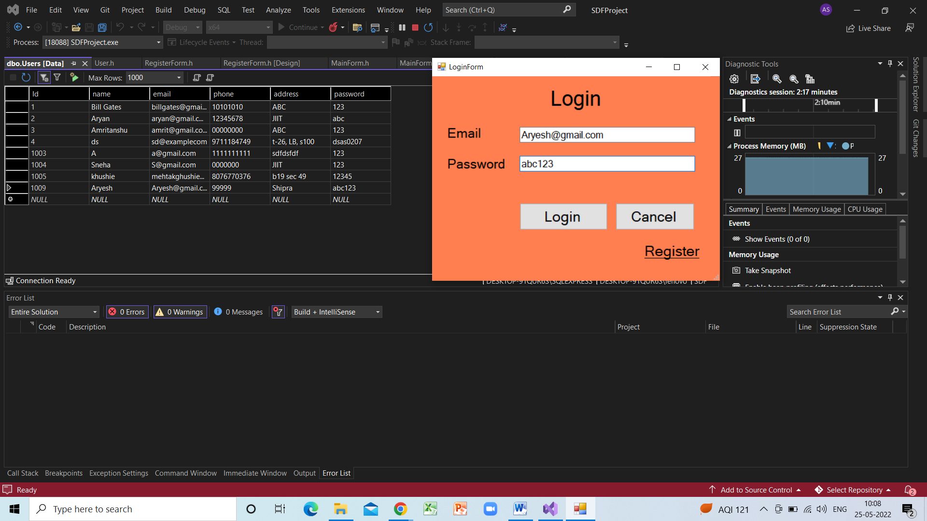

Successful Login:

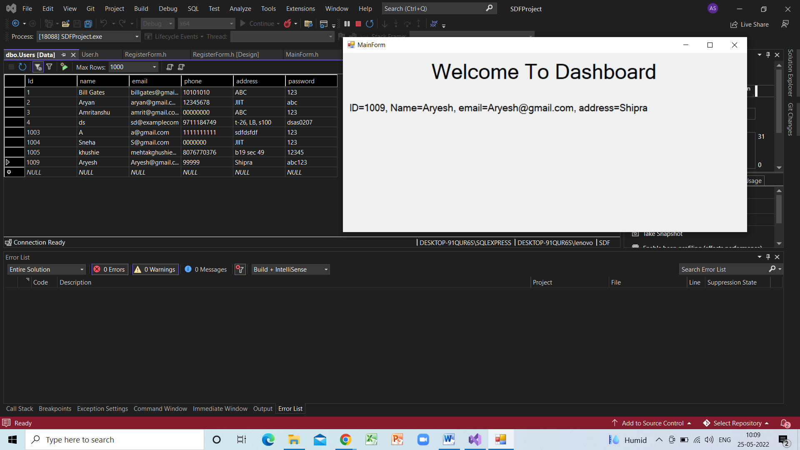

Registration:

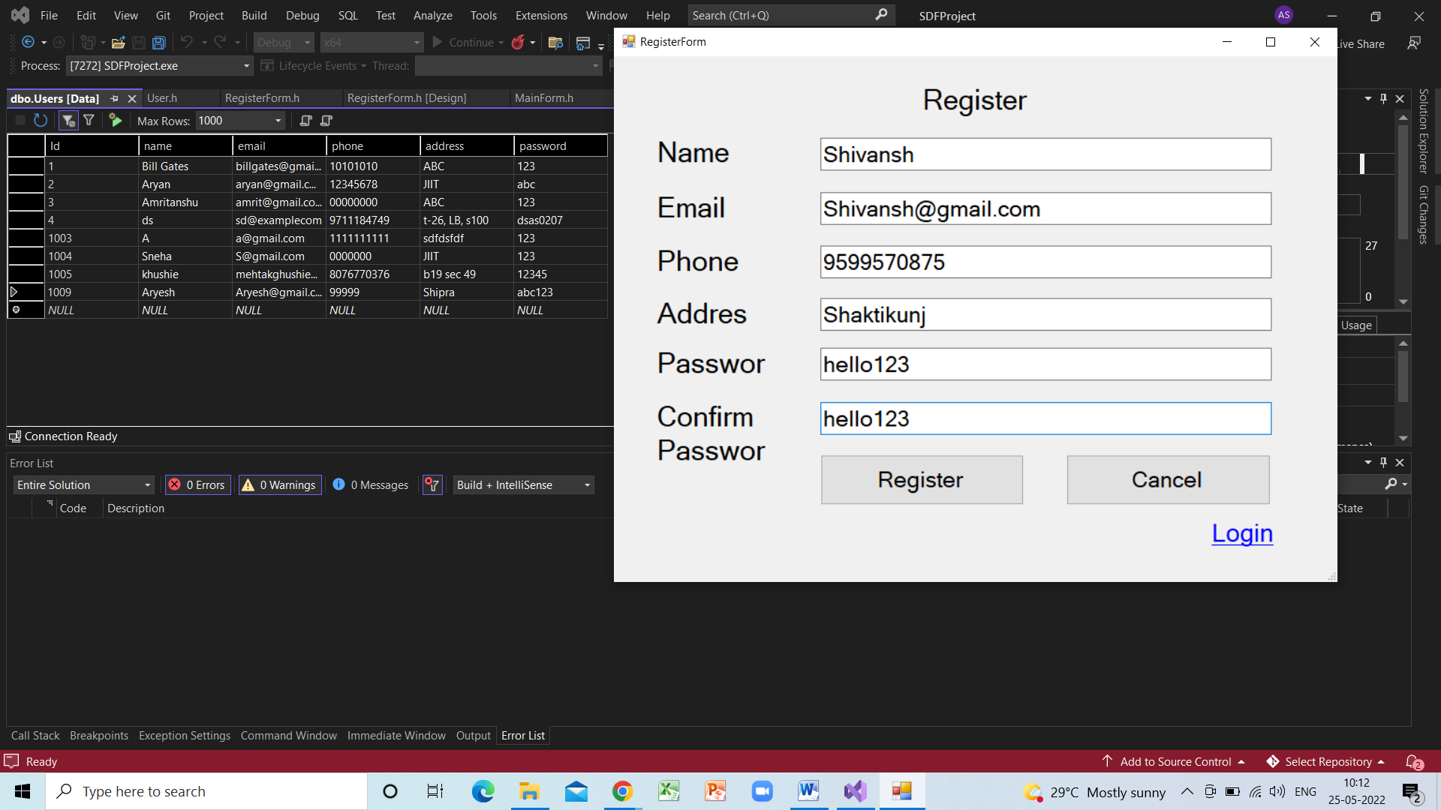

Successful Registration:

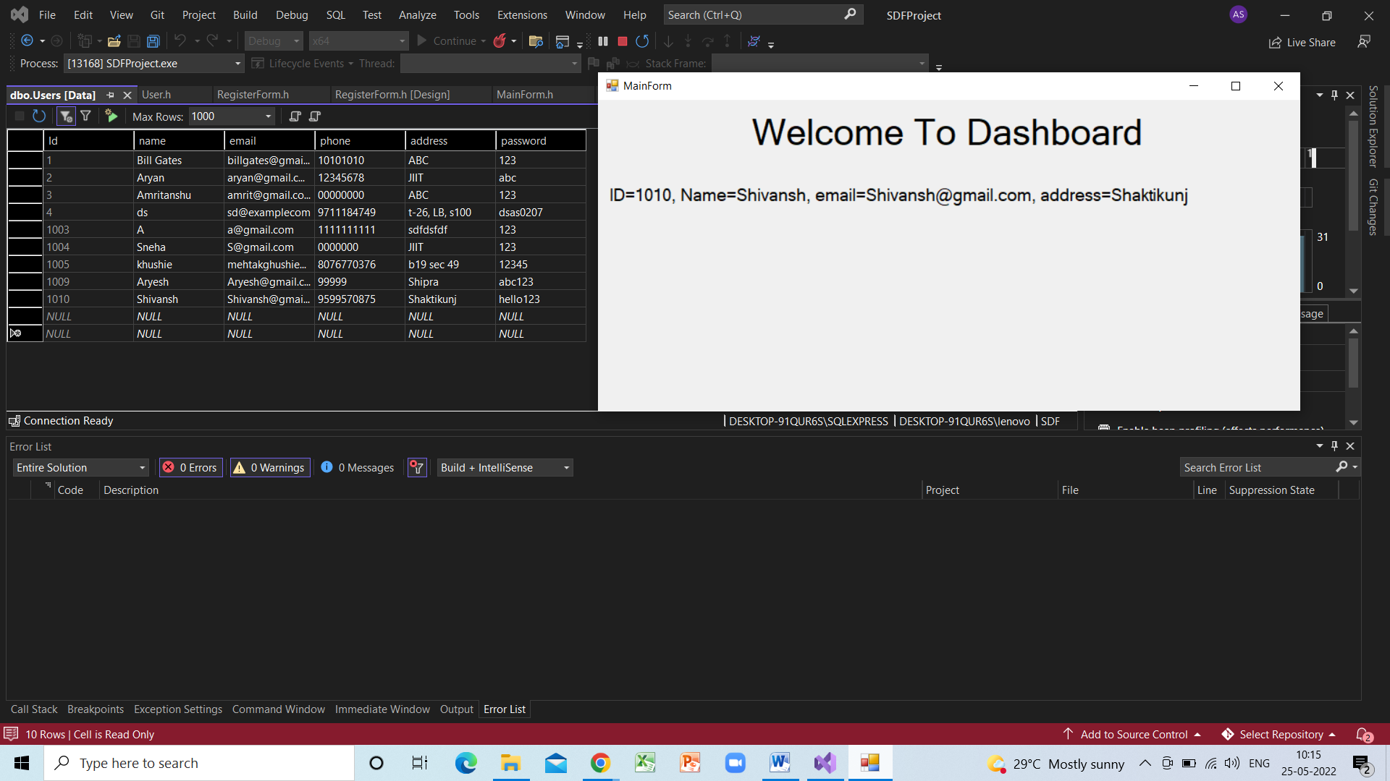

Error while Login:

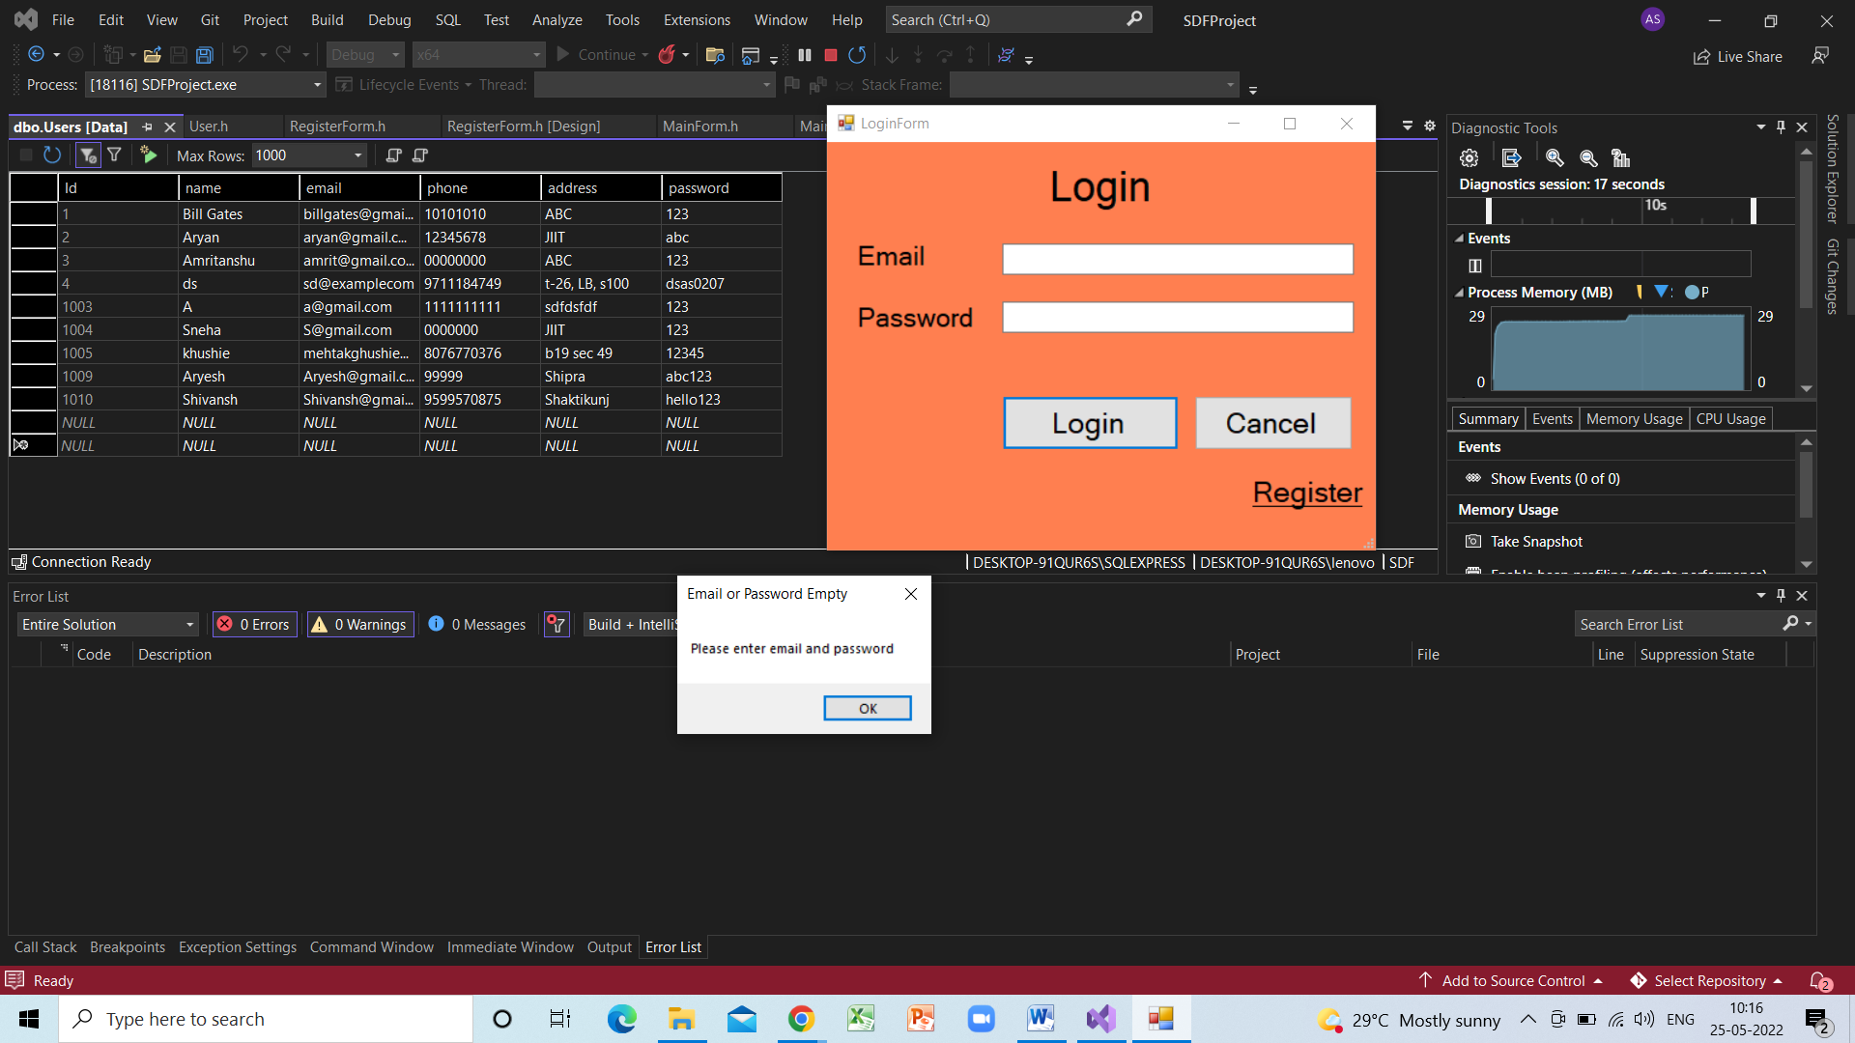

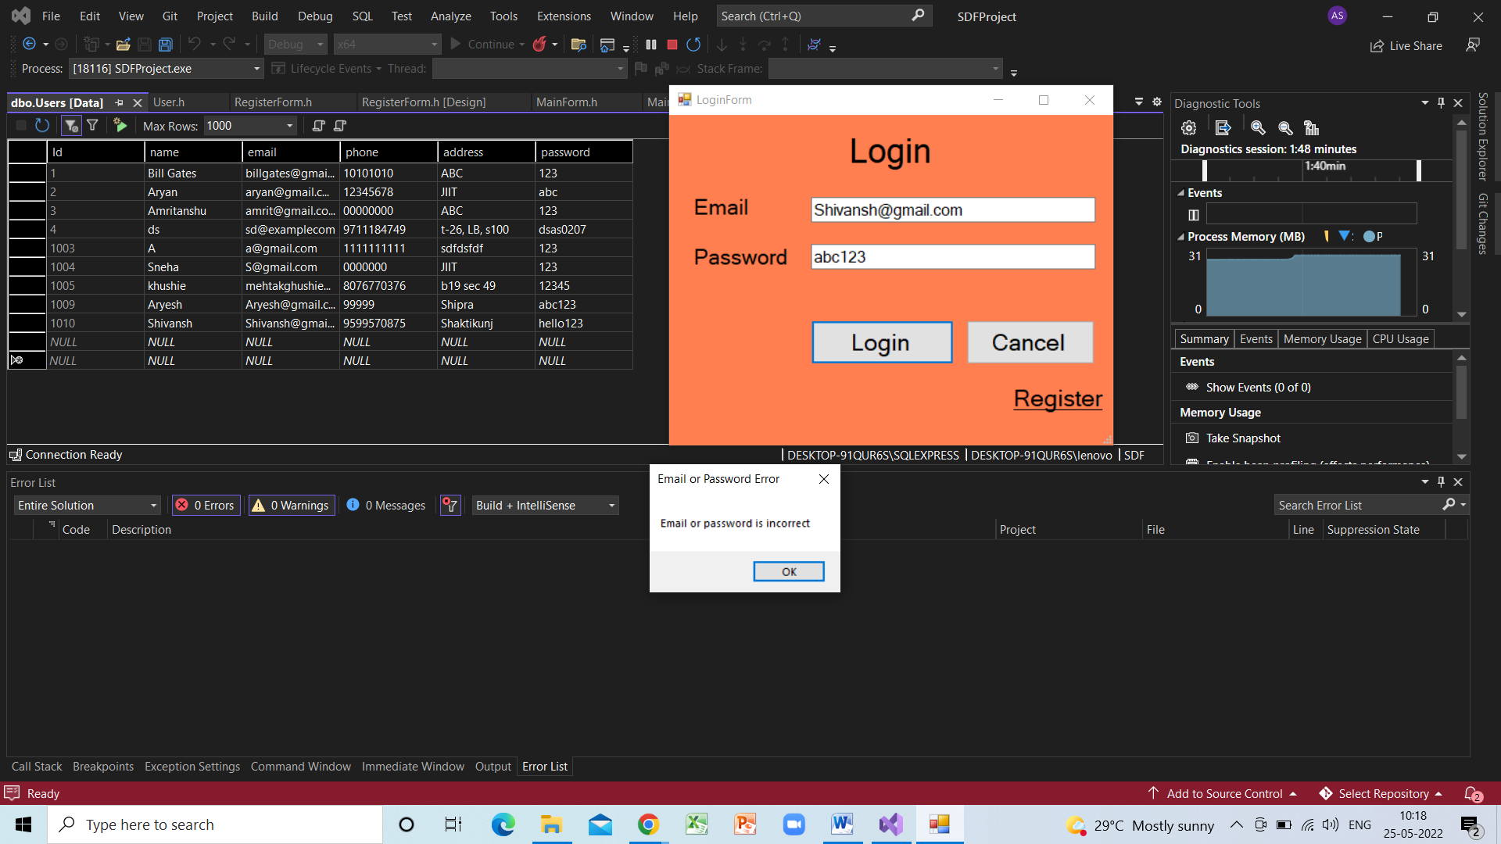

Error while Registration:

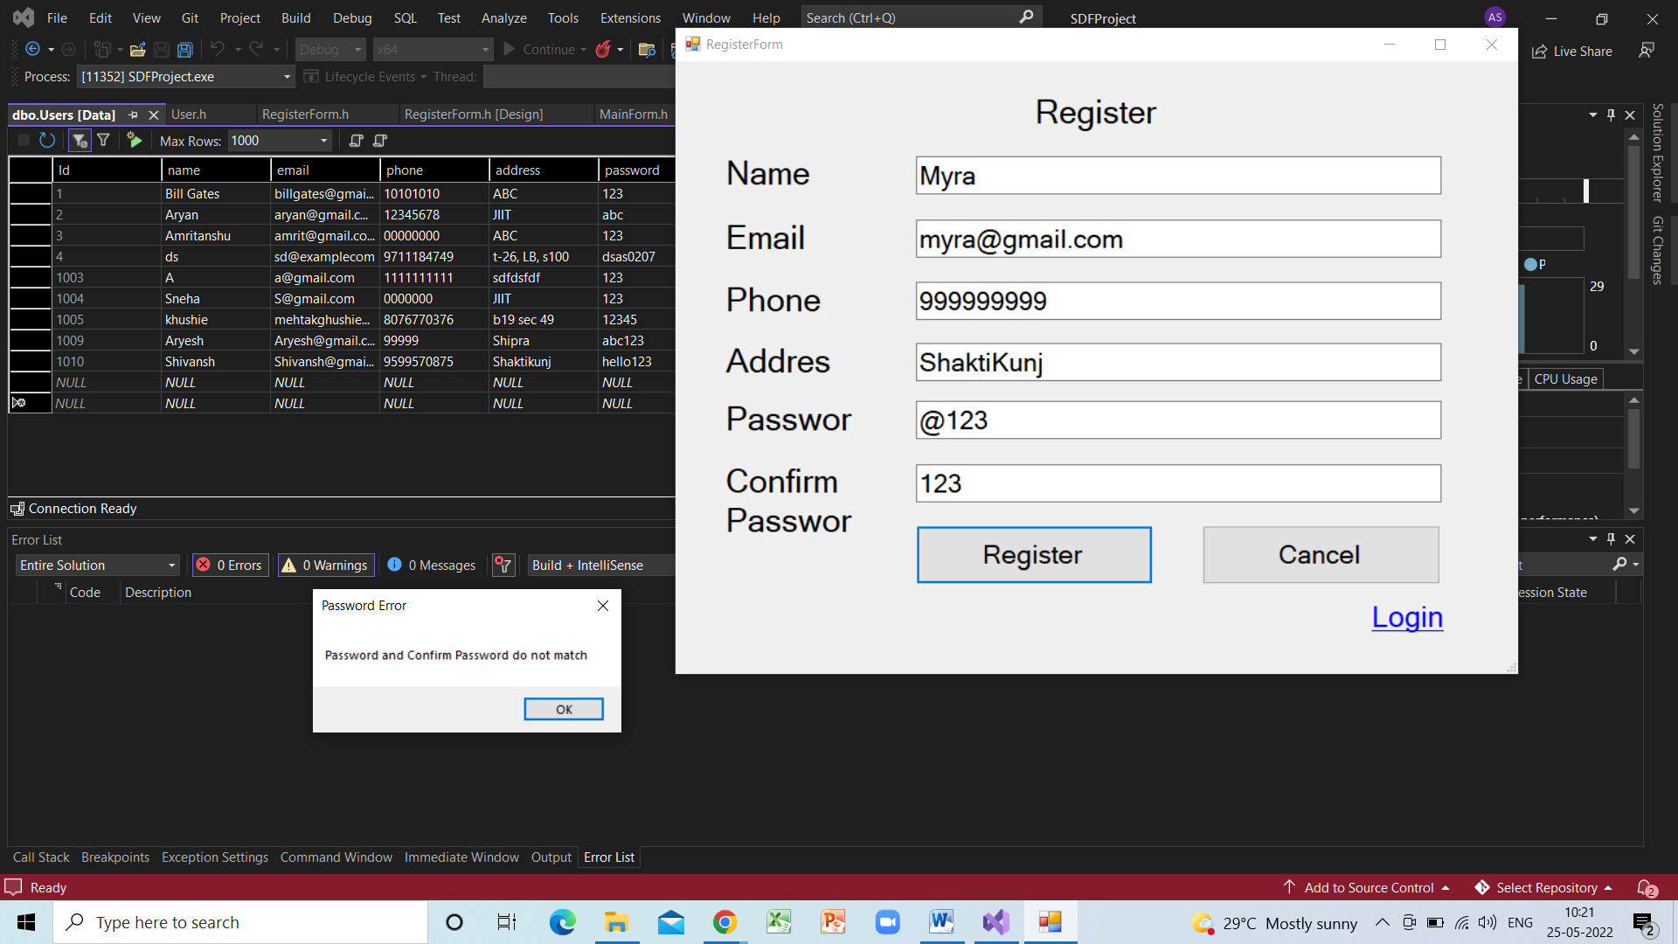

**References used:-**

* + YouTube
  + GeeksforGeeks
  + GitHub